IBMCLOUDSERVICES

SUCCESSFULLY CREATED IBM CLOUD SERVICES

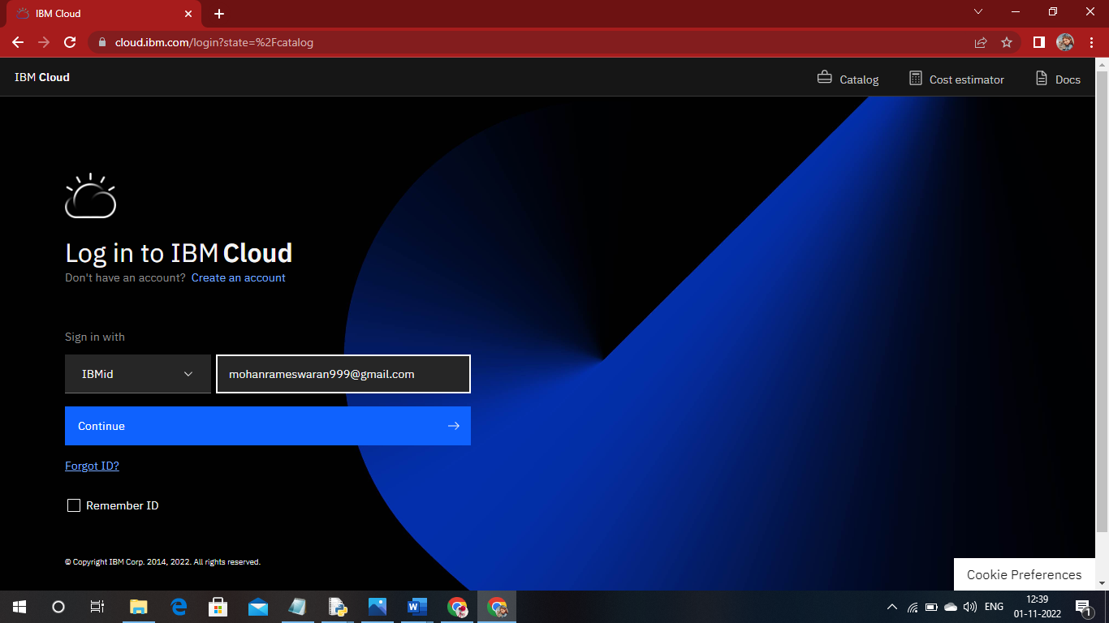

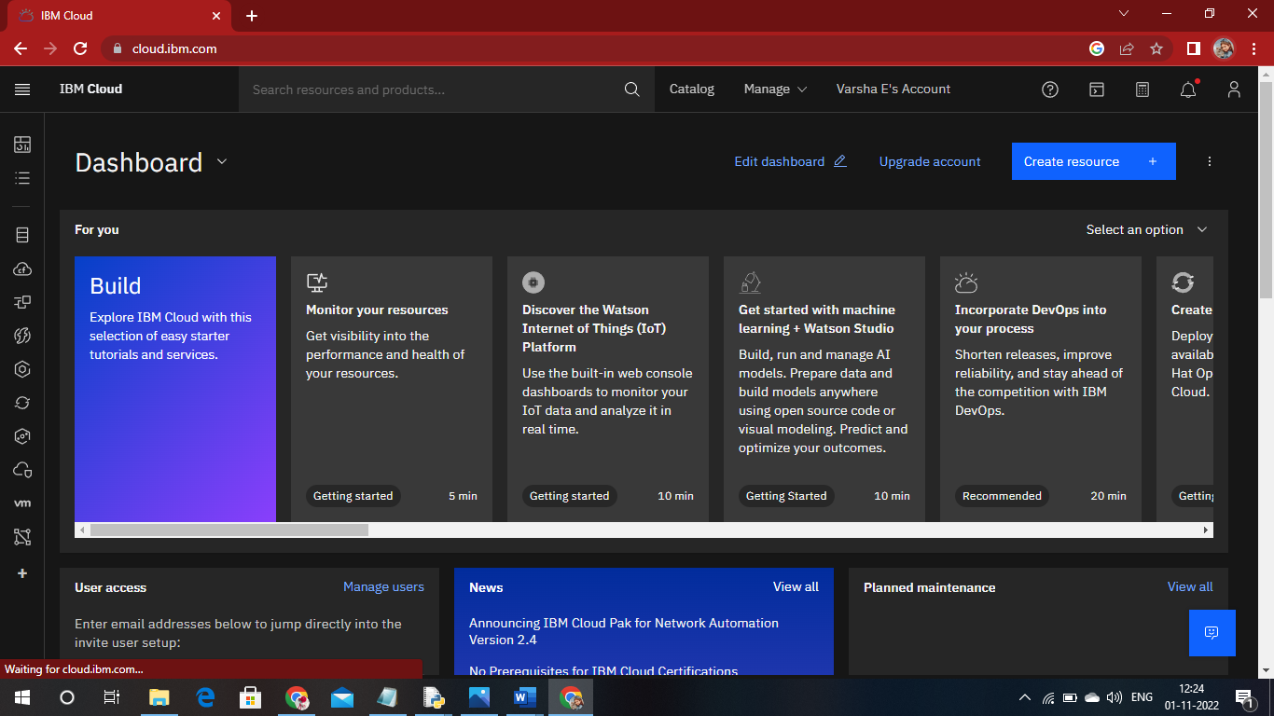

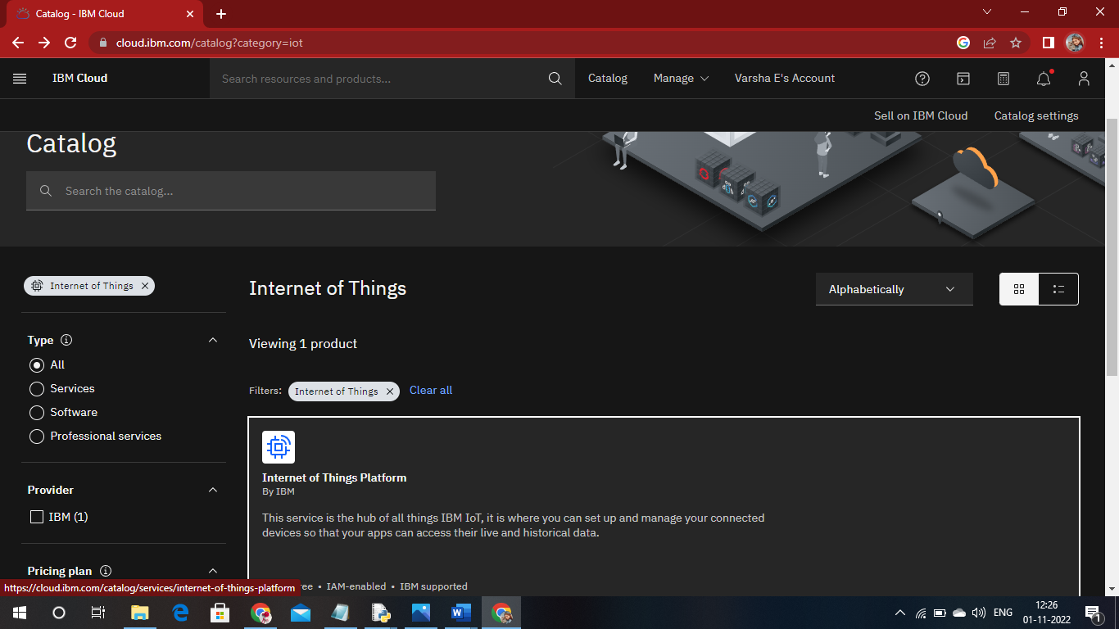

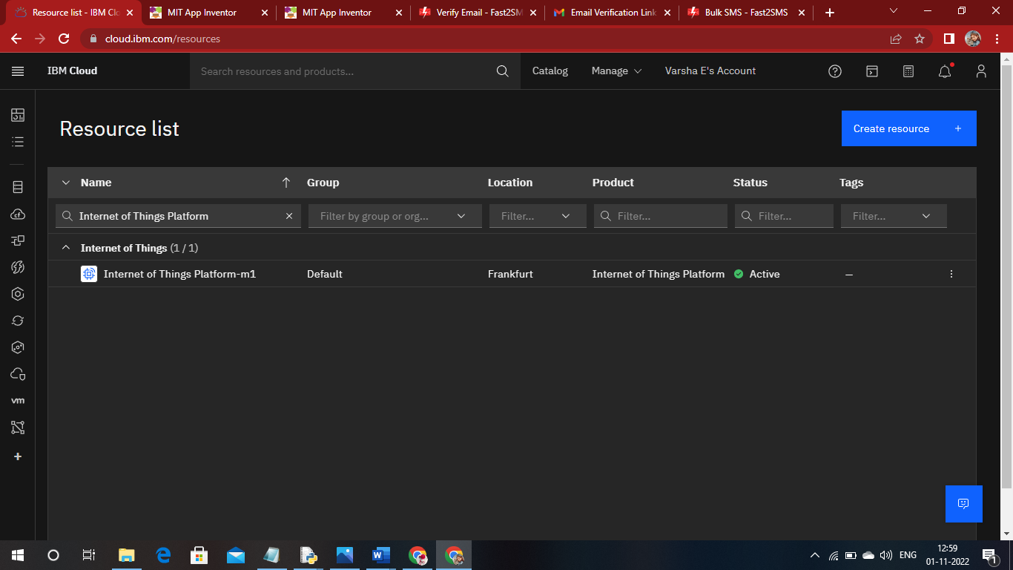

MIT APP INVENTER

SUCESSFULLY CREATED ACCOUNT IN MIT APP INVENTER

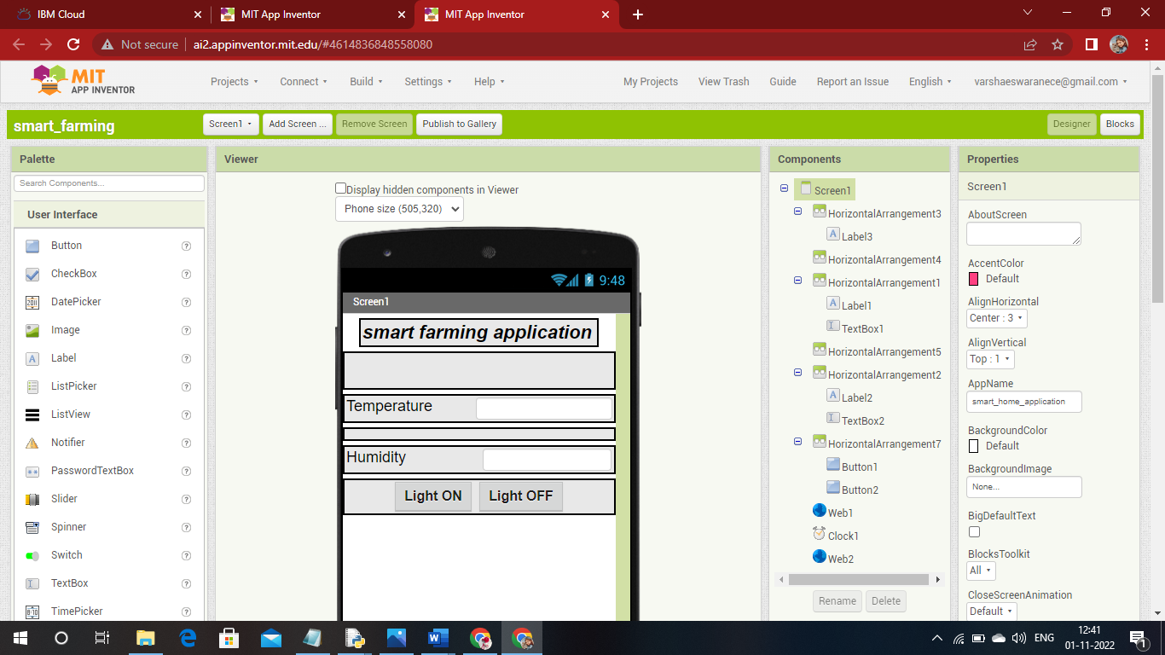

SOFTWARE:

THE REQUIRED SOFTWARE PYTHON 3.9.8 IS SUCESSFULLY INSTALLED

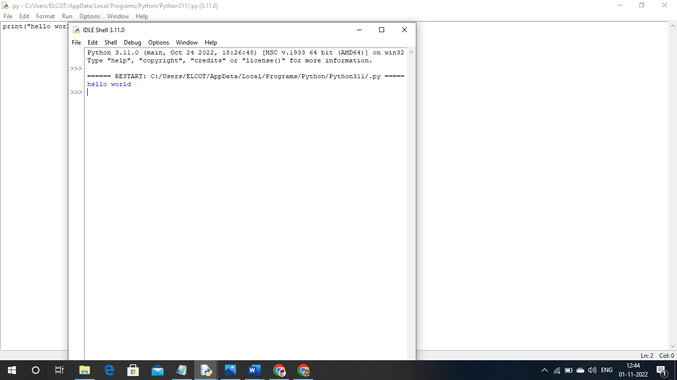

ACCOUNT IN FAST2SMS DASHBOARD:

ACCOUNT IN FAST2SMS DASHBOARD IS SUCESSFULLY CREATED

